This Fall Pockies Invites You To The House of Pockies
AMSTERDAM, NL - September 25, 2023 - As the leaves begin to fall and the air turns crisp, Pockies, the pioneers of comfort-focused homewear, extend a warm and stylish welcome to The House of Pockies. This Autumn/Winter, step into a realm of earthy nostalgia and sartorial elegance, where soft rugs, soothing 70s jazz, and the aroma of Mrs. Harrison's cooking set the stage for an unforgettable fashion journey.

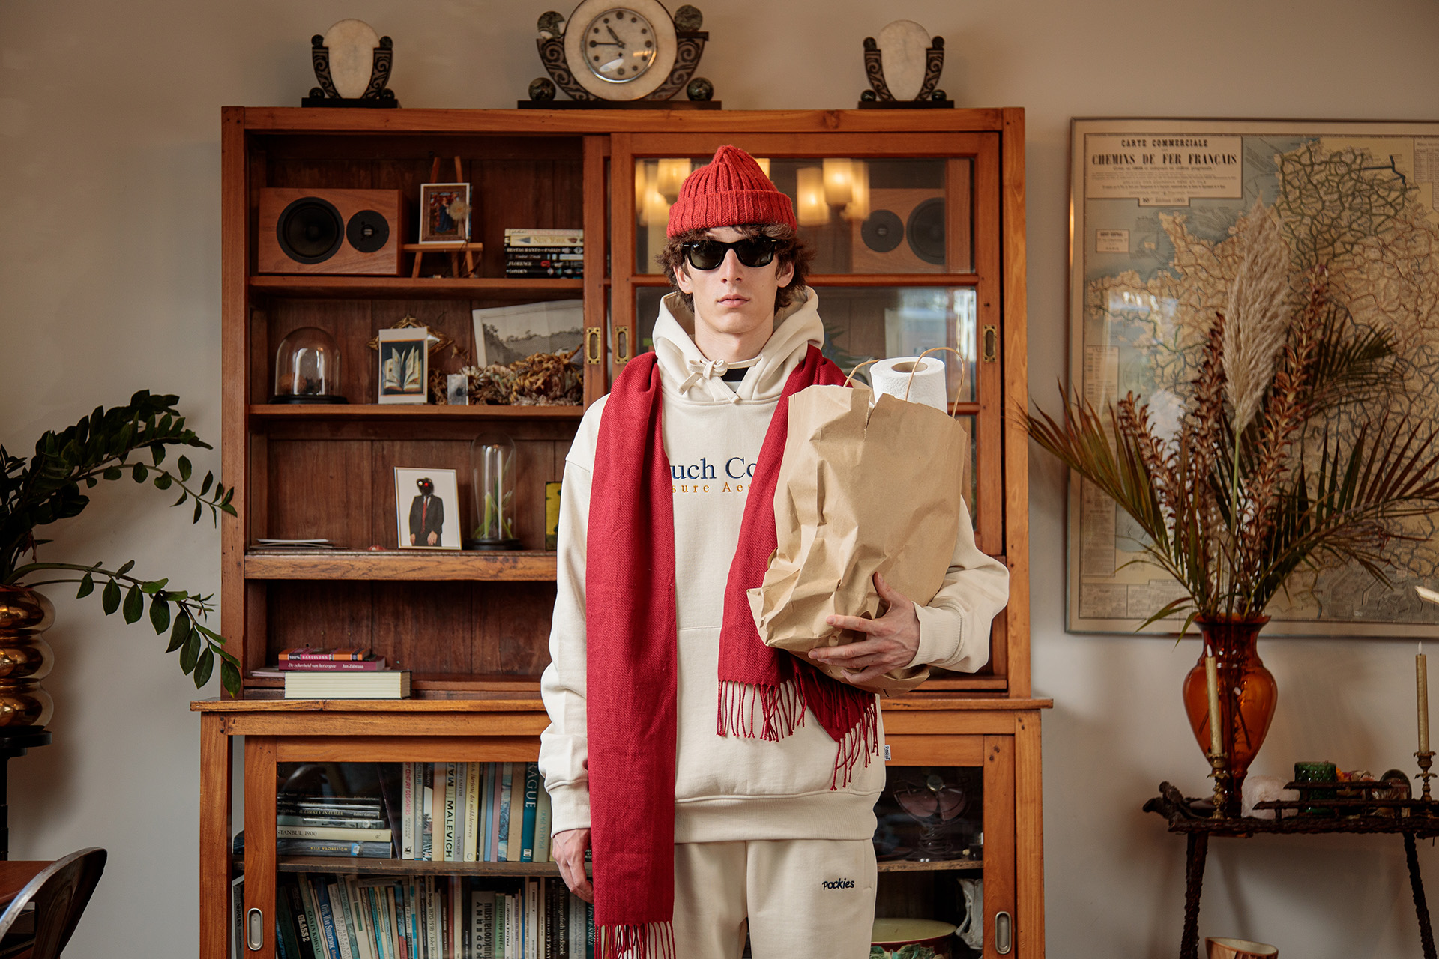

The House of Pockies: Where Nostalgia Meets Modernity

The House of Pockies invites you to shed the worries of the world at the doorstep and embrace the cozy sanctuary within. It's a place where warmth meets style, where you can escape the harsh weather while enveloped in the comforting embrace of nostalgia - or something pretentious fashion brands are expected to say about their collection.
A Feast for the Senses: The FW23 Collection

Pockies takes pride in presenting its highly anticipated FW23 collection, a curated ensemble of fashion essentials designed to elevate your comfort and style quotient. This season, the collection features a splendid array of Boxers, Briefs, Joggers, Quarter Zips, Hoodies, Pyjamas, Longsleeves, Yarn Died Shirts, and Heavyweight Socks.
Each piece in the collection reflects Pockies' unwavering commitment to innovation, quality, and sustainability. Crafted from the finest materials and designed with meticulous attention to detail, the FW23 collection is an embodiment of the brand's dedication to providing comfort and freedom in fashion.
A Glimpse into the Future of Loungewear

Pockies has long been a trailblazer in the world of loungewear, known for innovations such as the revolutionary boxer shorts with pockets. The FW23 collection continues this legacy, pushing the boundaries of loungewear fashion while preserving the timeless elements that make Pockies a beloved brand.
Availability

The House of Pockies and the FW23 collection are now open for exploration and available for purchase. Step inside, browse the collection, and discover the perfect pieces to accompany you through the autumn and winter seasons. You can check out the lookbook here:
https://pockies.com/pages/fw24-lookbook

Over: Pockies
Pockies started out in 2015 as a joke among friends when they created the first ever boxer shorts with pockets. Beyond all expectations, the first batch of underwear sold within no time laying the foundation to built their brand around their vision for Couch Couture. Pajamas, joggers, tees, thick socks and more followed and they have made it their personal life goal to spread comfort all over the planet

Newsroom
Bekijk het volledige persbericht inclusief meer foto's en video's in onze Newsroom.
Bekijk het volledige persbericht
Bekijk alle voorgaande persberichten

Contact informatie
Naam: michiel dicker
E-mail: michiel@pockies.com
Telefoon: +31621715581

