Underwear brand offers 'World's Laziest Job'
It sounds too good to be true: spend a day on the couch watching TV and earn &pound;500. But this is exactly the job that Amsterdam-based homewear-brand Pockies is offering. Through the job the company wants to discover what &lsquo;Couch Culture&rsquo; in the United Kingdom looks like.

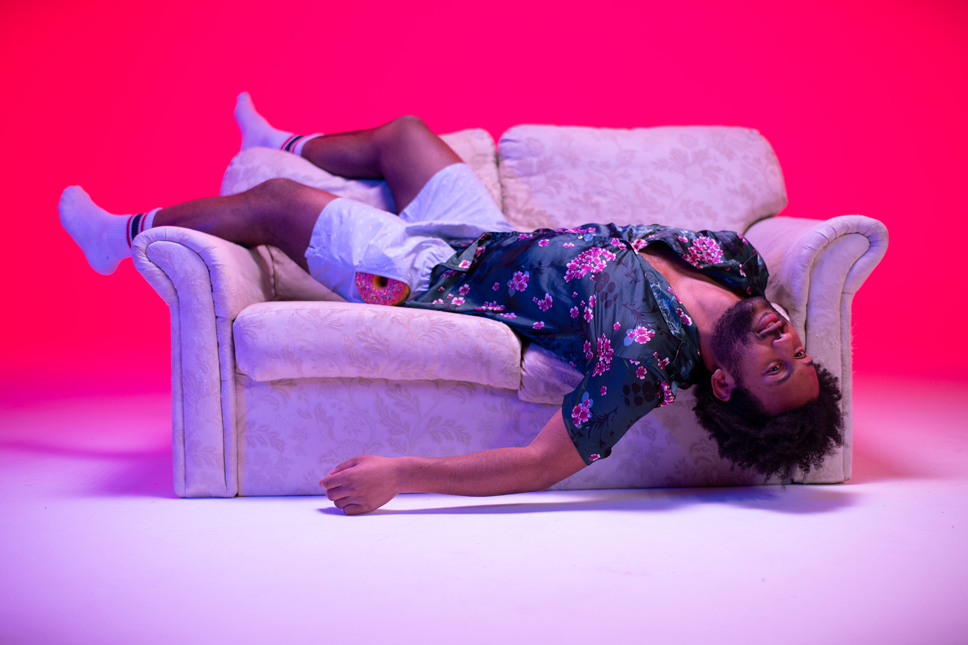

Not motivated and certainly no teamplayer
The job offer, that appeared on the
brand’s website
this morning, asks for a candidate who “has no ambition whatsoever,’ ‘is always late’ and ‘can snooze up to 10 times in a row’. What abilities does he or she need to have? You have to be able to spend a day on your couch in one of the company’s boxer shorts. “For us it is interesting to see what our British friends think of Pockies,” says Michiel Dicker, one of the founders. “Besides that, it gives us valuable insights into what a lazy day for someone living in the UK is like. That in turn will help us create new comfort enhancing products.”
Questionnaire

The person who gets the job has to fill in a questionnaire at the end of the day. “The questions range from commenting on the fit of our clothing to what the applicant’s favorite snack is,” says Dicker. Other than that there’s not much to it. “Just relax, check out your favorite show and keep breathing,” is the advice of Dicker. “The less productive you are, the greater the results.” If you think you have what it takes you can apply for the job until the end of the year.
Couch Culture
The founders of Pockies are dedicated to, what they themselves call, ‘
Couch Culture
’. “We want to make people’s lives on the couch as comfortable as possible,” says Dicker. Their journey started out five years ago with the invention of boxer shorts with pockets (so there wouldn’t be a need for trousers anymore), but since then their range of products has expanded with Pyjama Pants, Djellaba’s, Thick Socks, Cozy Hoodies and more. “Last year we even introduced Pocket-sized mayonnaise so our customers would always have their favorite condiment nearby.”

Apply here

https://www.uk.pockies.com/pages/couch-potato

Over: Pockies
Pockies started in 2015 as a joke between three students. One of the founders (Michiel Dicker) was lying on the couch in ‘regular’ boxer shorts. Nowhere to put his phone he thought out loud: “Why don’t boxer shorts have pockets?” The other two owners (Karel Bosman and Rob ten Hoove) thought it was a good idea and a business was born. Since the invention of boxer shorts with pockets, the company has extended its line of products with pyjama pants, djellaba’s, hoodies, socks and much more.

Newsroom
Bekijk het volledige persbericht inclusief meer foto's en video's in onze Newsroom.
Bekijk het volledige persbericht
Bekijk alle voorgaande persberichten

Contact informatie
Naam: Michiel Dicker
E-mail: michiel@pockies.com
Telefoon: 06-21715581

